Title of the Document

Online Exam System Project Design Document
Author: <Malcolm Li>
Last Updated: <Jul 25,2016>

Executive Summary if applicable
The design document has some class diagram,database design and entities relationship.
Document History
Date | Author | Summary of Change | Note
Jul 24,2016 | Malcolm Li | Increase the class diagram, Database Schema and the entities relationship
Jul 25,2016 | Malcolm Li | Refine the class diagrams.
<Table of Contents>

Overview 4
High Level Architecture 4
Detail Design 4
Class Diagram 4
Sequence Diagram 4
Entities and Relationship 8
Detail Database Schema 8
Table User 8
Table User_type 9
Table Exam 9
Table Question 9
Table Question_exam 9
Table Answer 9
Table Exam_status 9
Table User_exam 10
Interface Definitions 10
APIs/Interfaces 10
User Interfaces 10
Error and Exception Handling 10
Other Design Considerations 10

Overview
Online Exam System has the client and web system. The web system provides user management, question’ management and exam management functions. The user with SysAdmin can manage all users including create, edit, delete user. The user with ContentAdmin can manage all questions and exams. The client System has two role Studnt and Teacher.Student can take one of not finished exams. Student can see his all exams. Teacher can see the student list, and review all finished exam and statistics information.

High Level Architecture
This project will use the MVC design mode. And the system has 4 layer include(Model, Dao, Service and servlet). When the request comes, the servlet will use the service. In service, it will use the dao to finish some task like select, update, delete etc. And the model will be used by Dao.
The front-end will use the jsp to design some page like login page, select page, etc.

Detail Design

Class Diagram
List all class diagrams into here. <Draw diagram tool: Jude or its latest version Astah>

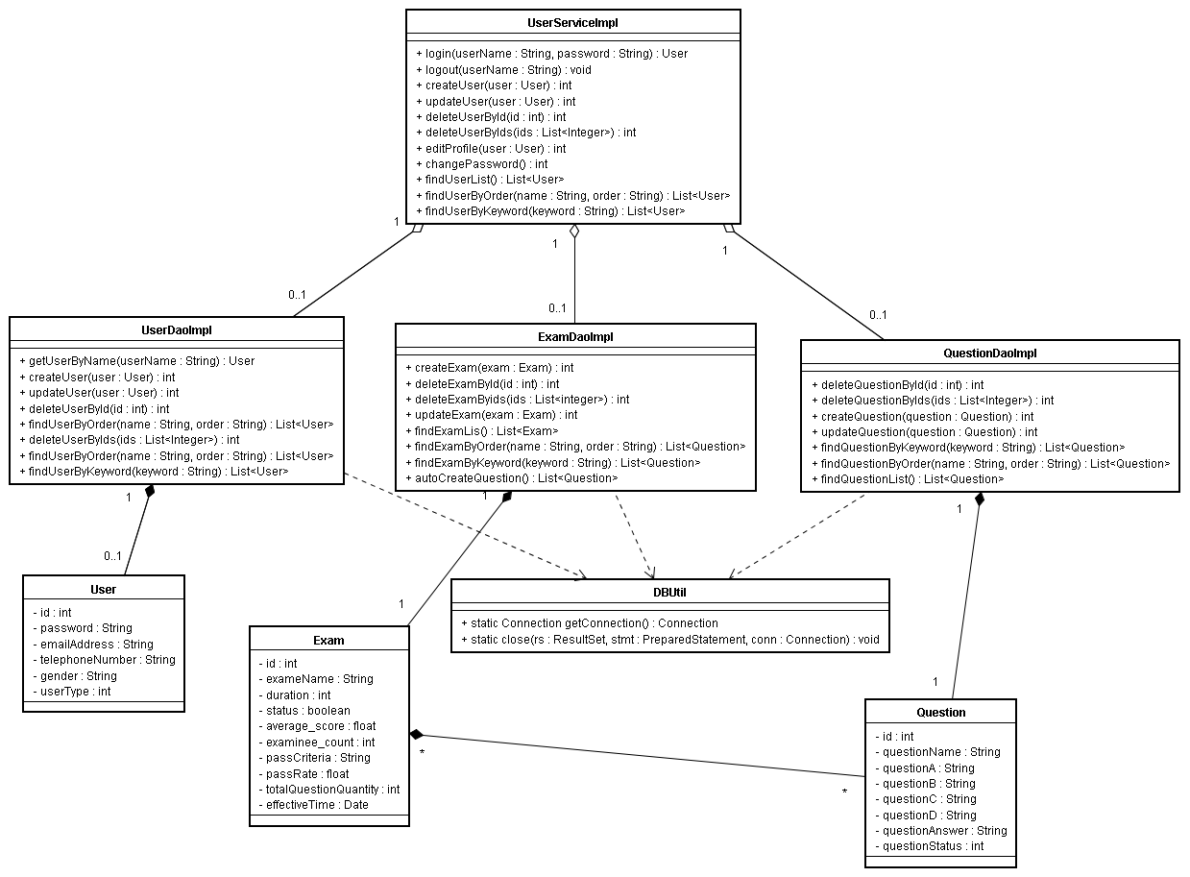

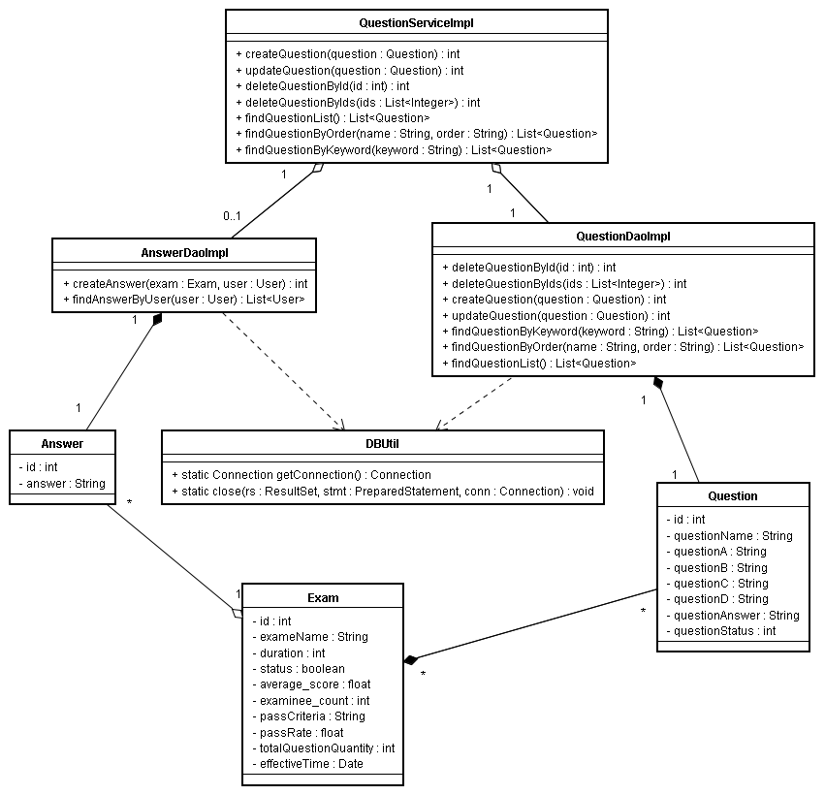
Sequence Diagram

1. Create question in diagram 1. ContentAdmin execute the method named “createQuestion” by the object of QuestionServiceImpl. Then verify the question is null or not null, If the question is not null, System will execute the method named “createQuestion” by the object of QuestionDaoImpl.
And System will return the execute result named count.
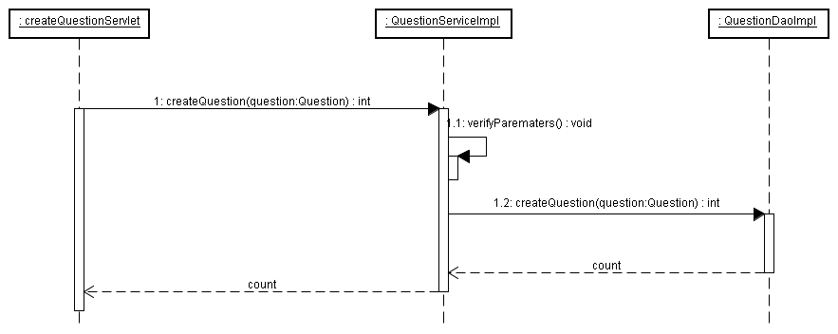
Diagram1
2. Update question in diagram 2. ContentAdmin execute the operate of update the question, will enter the UpdateQuestionServlet. And the servlet will execute the “updateQuestion” method by the object of QuestionServiceImpl. Then it will verify the question. If it is ok, the object of QuestionDaoImpl will execute the “updateQuestion” method. It will execute the “createQuestion” method to create a same question. But the original question's status will be set false. Then it will return the execute count.
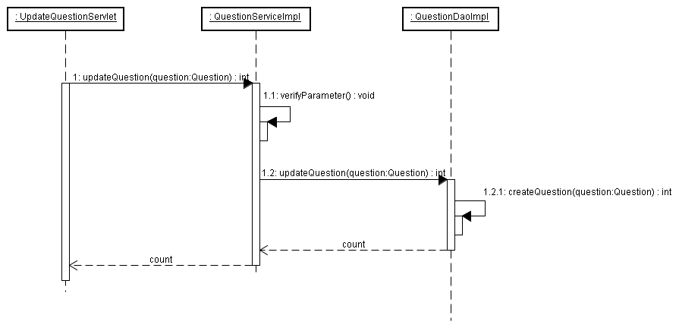
Diagram 2
3. Delete question by id in diagram 3. ContentAdmin execute the operate of delete the question by id, will enter the DeleteQuestionByIdServlet. It will verify the id. If it it ok, the object of QuestionDaoImpl will execute the “updateQuestion” method. But it will just update the status of the deleted question. Then it will return the execute result count.
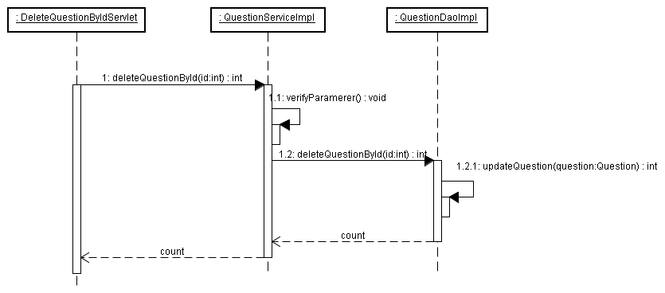
Diagram 3
4. Delete question by ids in diagram 4. ContentAdmin execute the operate of delete the question by ids will enter the DeleteQuestionByIdsServlet. Then it will verify the ids. If it is ok, the object of QuestionServiceImpl will execute the “deleteQuestionByIds” method. And the method will loop the list to update the question's status for all question by the “updateQuestion” method. Then it will return the execute result count.
.
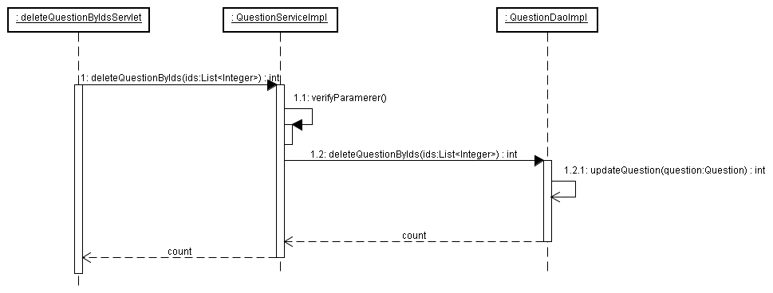
Diagram 4
5. Find question list in diagram 5. ContentAdmin execute the operate of find question list will enter the FindQuestionListServlet. And the object of QuestionServiceImpl will execute the “findQuestionList” method. In this method, the object of QuestionDaoImpl will execute the “findQuestionList” method. Then it will return the execute result named userList.
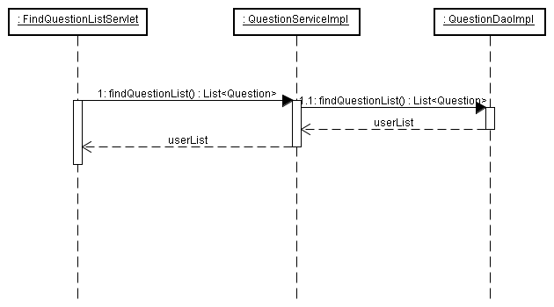
Diagram 5
6. Find question list by keyword in diagram 6. ContentAdmin execute the operate of find question list by keyword will enter the FindQuestionByKeywordServlet. In this servlet, the object of QuestionServiceImpl will execute the “findQuestionByKeyword” method. In this method, it will verify the keyword. If it is ok, the object of QuestionDaoImpl will execute the “findQuestionByKeyword” method. Then it will return the execute result named questionList.
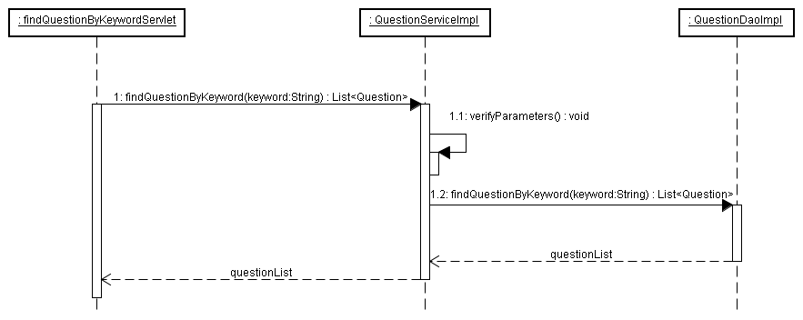
Diagram 6
7. Find question list by order in diagram 7. ContentAdmin execute the operate of find question list by order will enter the FindQuestionByOrderServlet. In this servlet , the object of QuestionServiceImpl will verify the name and order. If it is ok, it willexecute the “findQuestionByOrder” method. In this method, the object of QuestionDaoImpl will execute the “findQuestionByOrder” method. Then it will return the execute result named questionList.

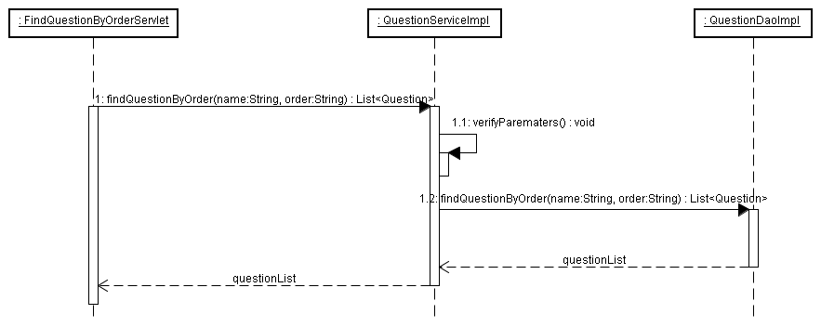
Diagram 7

Entities and Relationship

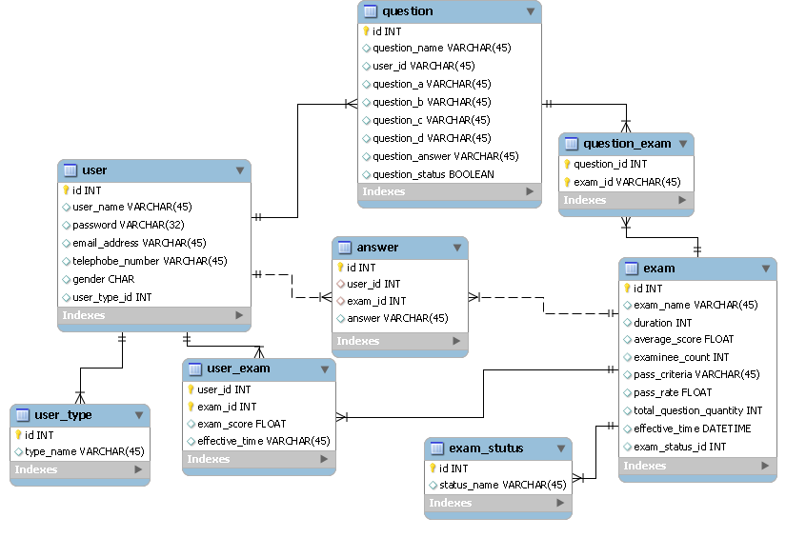
Detail Database Schema

Table User
Field Name | Data Type | Size | Null? | Comment
id | Int | 5 | No | Primary key
user_name | Varchar | 20 | No | User's ID
password | Varchar | 20 | No | User's password
email_address | Varchar | 30 | No | User's email address
telephone_number | Varchar | 20 | No | User's telephone number
gender | Varchar | 10 | No | User's gender
user_type | Int | 5 | No | User's type

Table User_type
Data Type | Size | Null? | Comment
Int | 5 | No | Primary key
Varchar | 30 | No | User's type name

Table Exam
Field Name | Data Type | Size | Null? | Comment
id | Int | 5 | No | Primary key
exam_name | Varchar | 20 | No | Exam's name
duration | Int | 10 | No | Exam's duration
average_score | Float | 20 | No | Exam's average score
examinee_count | Int | 20 | No | Exam's examinee count
pass_criteria | Varchar | 20 | No | Exam's pass criteria
pass_rate | Float | 10 | No | Exam's pass rate
total_question_quantity | Int | 10 | No | Exam's total question quantity
effective_time | DateTime |  | No | Exam's effective time
exam_status_id | Int | 10 | No | Exam's status id, foreign key

Table Question
Field Name | Data Type | Size | Null? | Comment
id | Int | 5 | No | Primary key
question_name | Varchar | 10 | No | Question’s name
user_id | Int | 10 | No | User's id
question_a | Varchar | 50 | No | Question’ A option
question_b | Varchar | 50 | No | Question’ B option
question_c | Varchar | 50 | No | Question’ C option
question_d | Varchar | 50 | No | Question’ D option
question_answer | Varchar | 50 | No | Question’s answer
question_status | Boolean |  | No | Question’s status

Table Question_exam
Field Name | Data Type | Size | Null? | Comment
question_id | Int | 5 | No | Question’s id, foreign key
exam_id | Int | 5 | No | Exam's id

Table Answer
Field Name | Data Type | Size | Null? | Comment
id | Int | 5 | No | Primary key
user_id | Int | 10 | No | Foreign key, user's id
exam_id | Int | 10 | No | Foreign key, exam's id
answer | Varchar | 30 | No | User's answer

Table Exam_status
Field Name | Data Type | Size | Null? | Comment
id | Int | 5 | No | Primary key
status_name | Int | 20 | No | Exam's status

Table User_exam
Field Name | Data Type | Size | Null? | Comment
user_id | Int | 10 | No | Foreign key, user's id
exam_id | Int | 10 | No | Foreign key, exam's id
exam_score | Int | 10 | No | Exam's score
effective_time | DateTime |  | No | Exam's Effective time

Interface Definitions
If this project delivers a set of APIs or interfaces, then this section describes what they are.

APIs/Interfaces
Name of the APIs or interfaces being developed and delivered to end users.
Name and description of the methods in each interface.

Each API/Interface should have unique ID for cross reference purposes (FSI0001, FSI0002, etc.)

User Interfaces
Please refer to formal User Interface Specification Template.

Error and Exception Handling
What is the behavior of features under error conditions?
What feedback mechanisms of error condition does the feature have?

In case end users are software developers who are embedding this component, also use this section to identify errors and exceptions that his component generates for the downstream error handling routines.

Other Design Considerations
You can add other design considerations into here. For example, consider to contribute public component into company standard component repository, consider to open source part of code, consider to use exist standard component, etc.

